Cloud Computing Lab

Safa Jahangir
BSE-V B
2023-BSE-056

LAB 05

Task 1 - Discover missing command & install Java using apt suggestion
- task1_java_suggestion.png
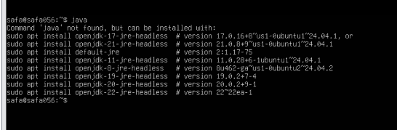
- task1_java_install.png
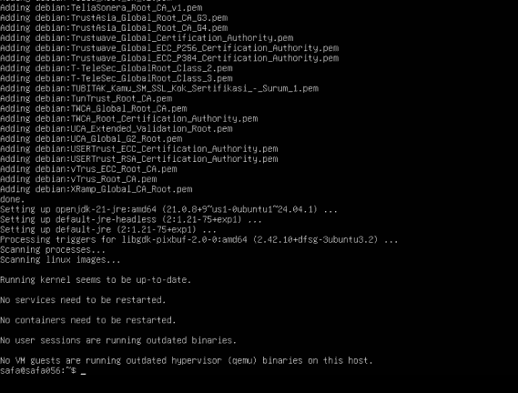
- task1_java_version.png
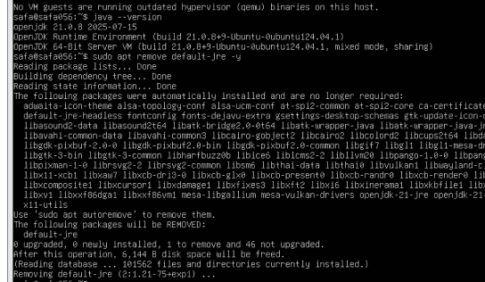
- task1_java_remove.png
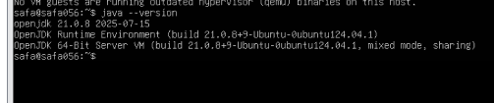
- task1_java_not_found.png
- task1_hash_clear.png
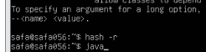

Task 2 - Install & remove Java using apt-get (explicitly)
- task2_aptget_install.png
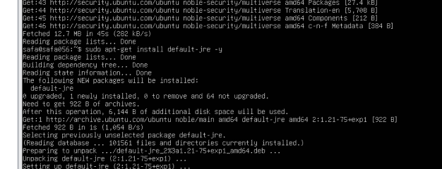
- task2_java_version_after_aptget.png
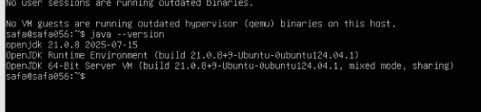
- task2_aptget_remove.png
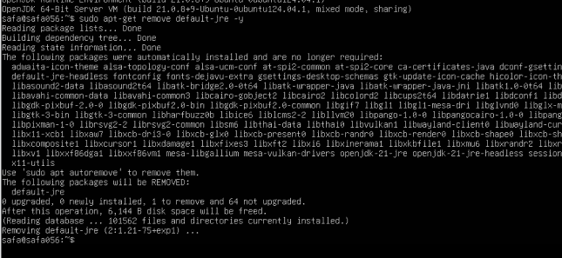
- task2_hash_after_remove.png

Task 3 - apt update vs apt upgrade - run & explain
- task3_apt_update.png
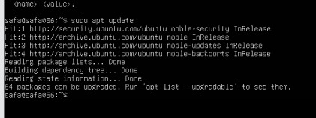
- task3_apt_upgrade.png
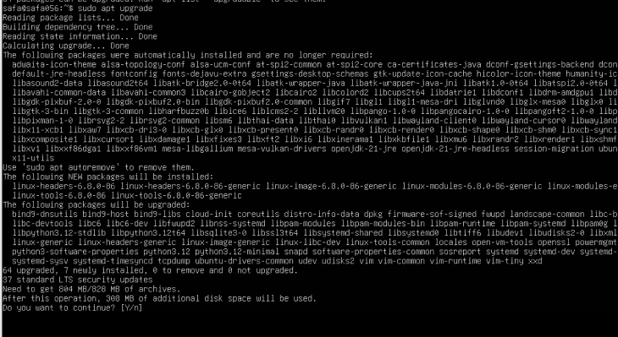
task3_explanation.png

Task 4 - Install Visual Studio Code via snap on CLI and verify (DO NOT remove Code)
- task4_snap_install.png
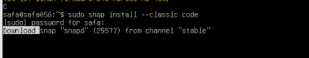
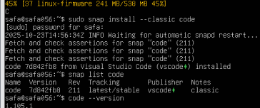
- task4_snap_list.png
- task4_code_version_or_info.png
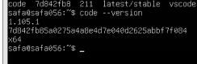
- task4_snap_bin_location.png
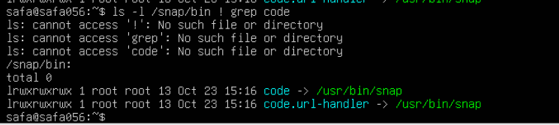

Task 5 - Install XFCE GUI + XRDP - minimal desktop and remote access (GUI) and launch VS Code
- task5_update.png
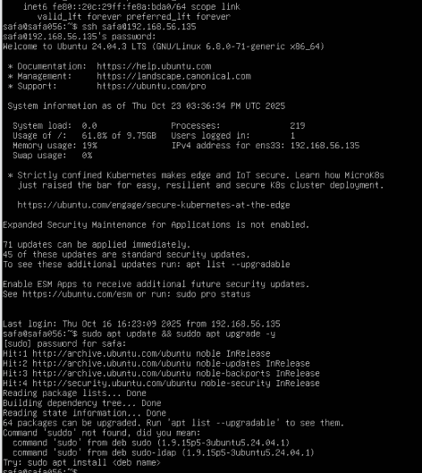
- task5_xfce_install.pn
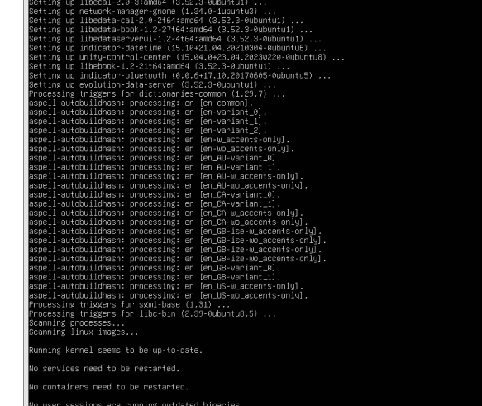

- task5_xrdp_enable.png
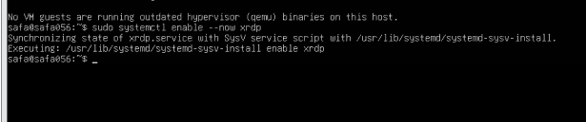
- task5_xrdp_status.png
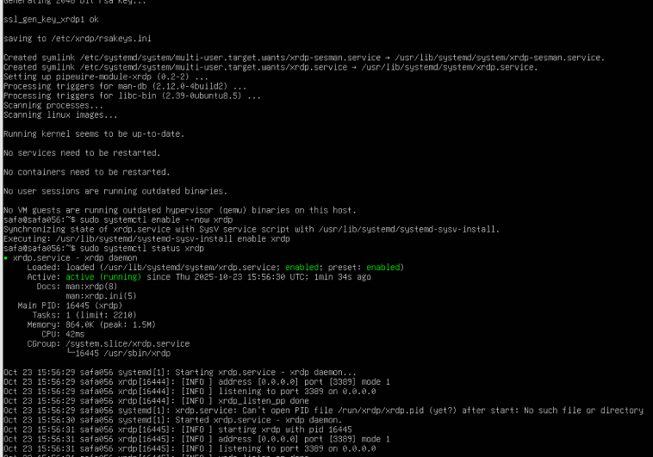
- task5_xsession.png
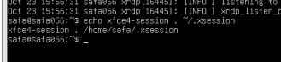
- task5_rdp_connect.png
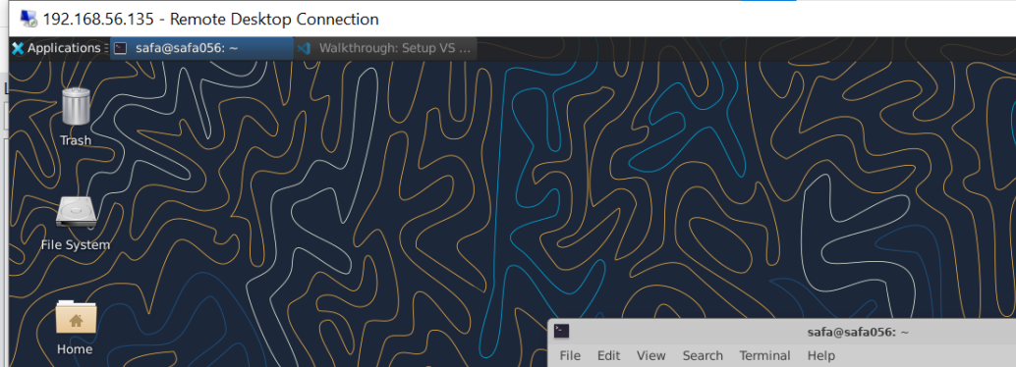
- task5_vscode_launch.png
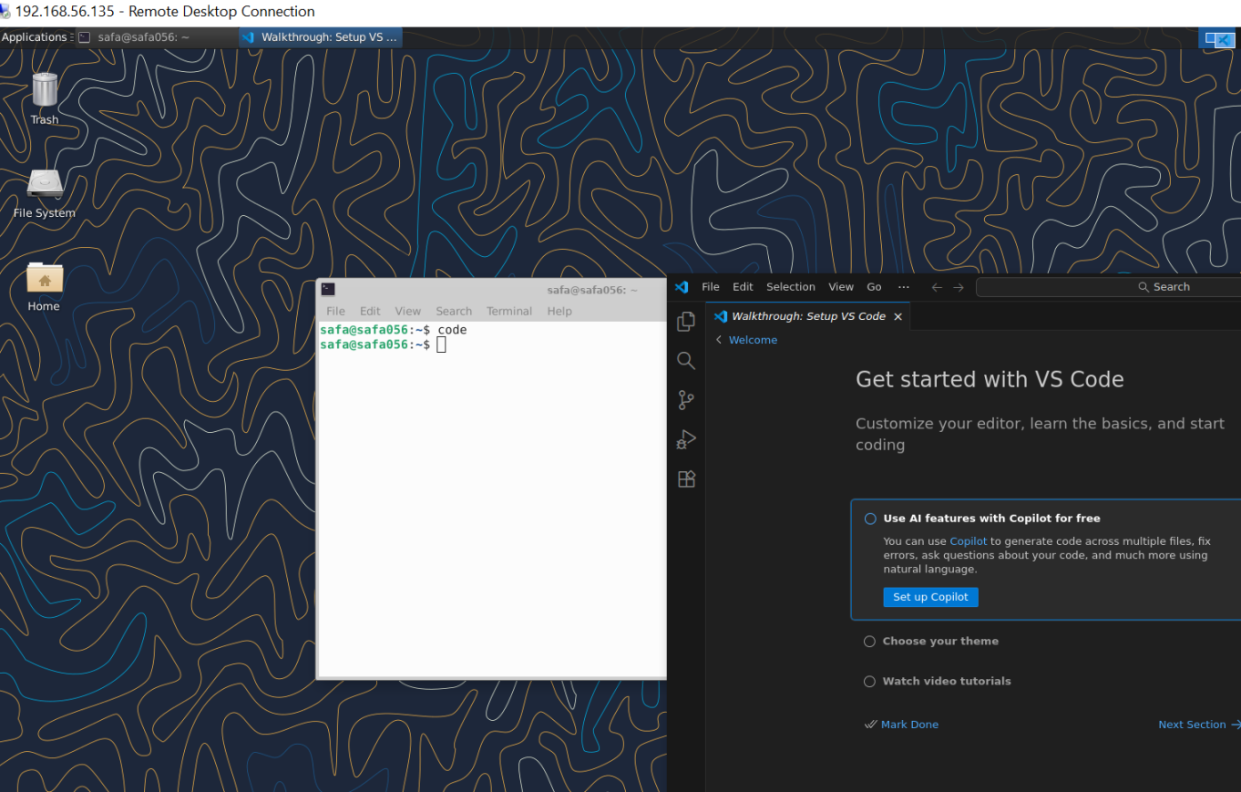

Task 6 - Install lightdm-gtk-greeter and GUI verification - start GUI, open VS Code, take snapshot, then end (GUI)
- task6_lightdm_install.png
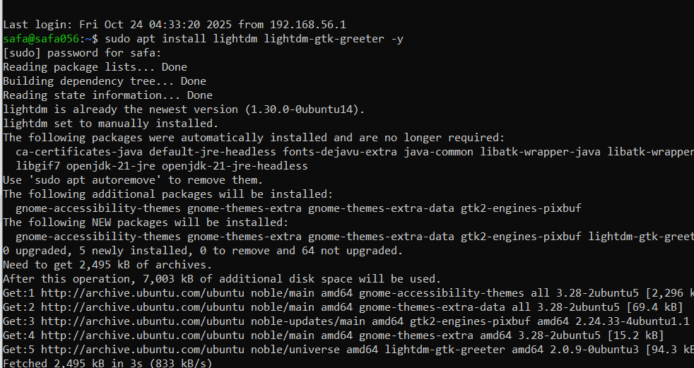
- task6_lightdm_config.png
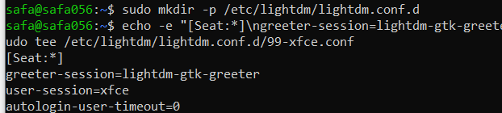
- task6_lightdm_cleanup.png
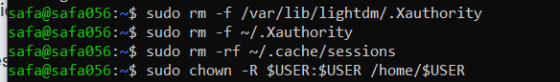
- task6_lightdm_restart.png
- task6_gui_enable_boot.png
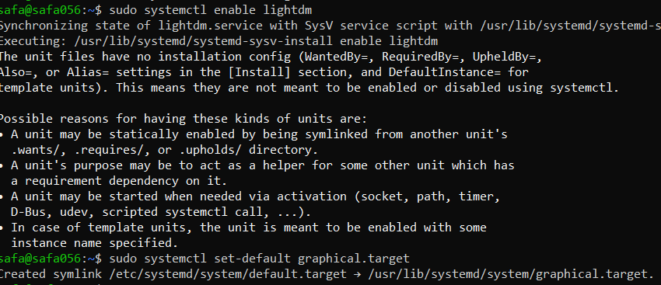
- task6_after_reboot_gui.png
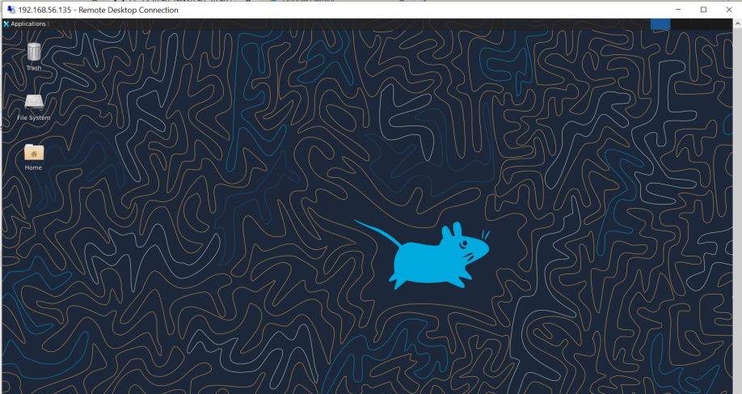
- task6_gui_disable_boot.png
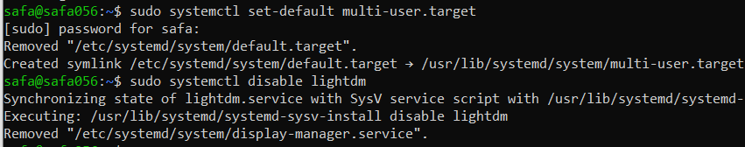
- task6_after_reboot_cli.png
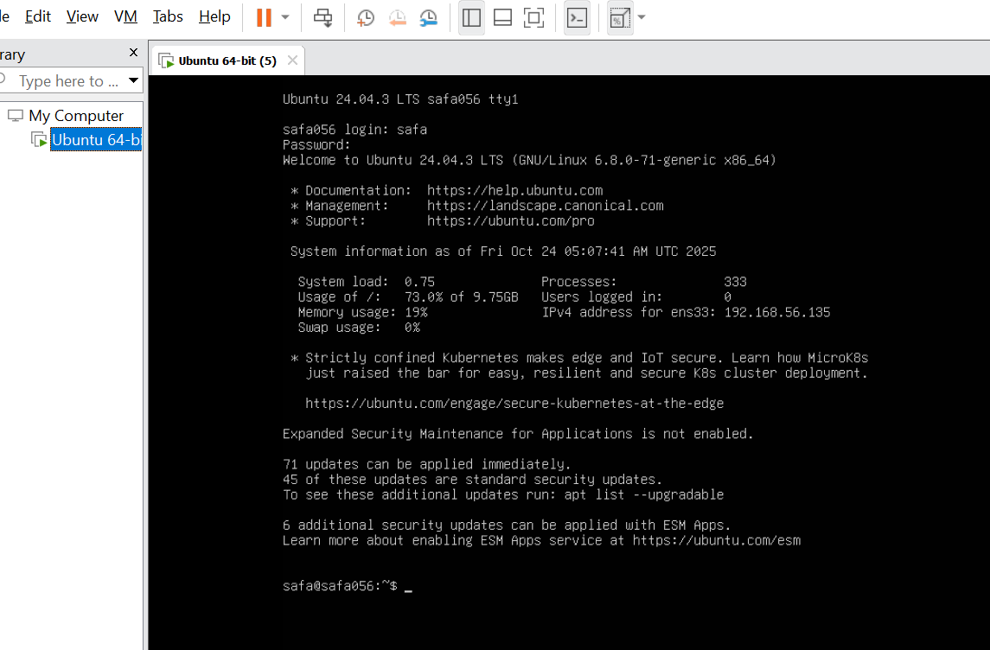
- task6_gui_start.png
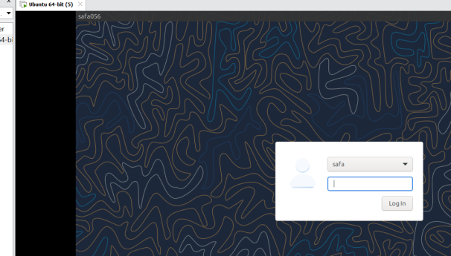
- task6_gui_stop.png
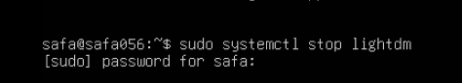
- task6_gui_start_command.png
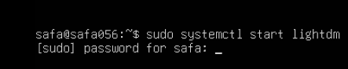
- task6_vscode_launch.png
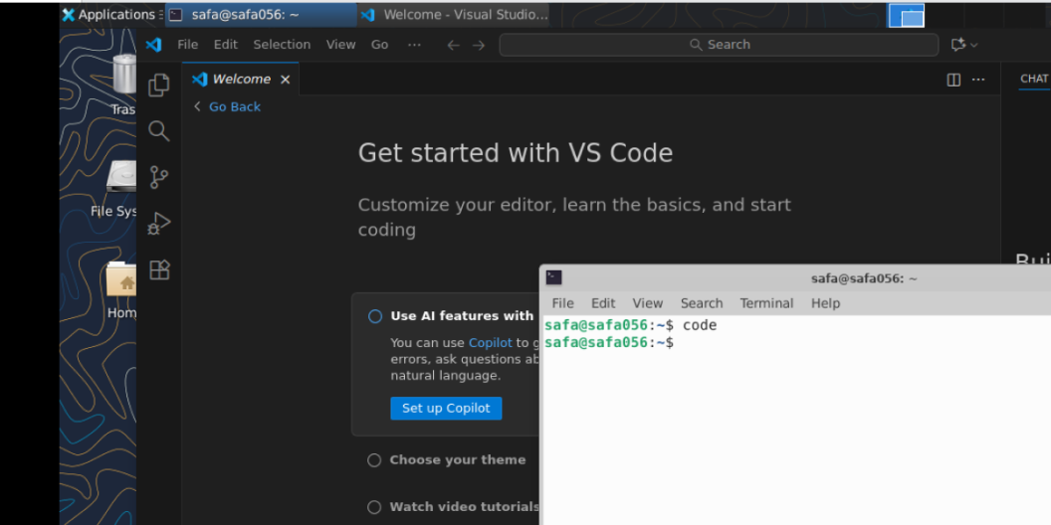

Task 7 - Install Google Chrome by adding its apt source & key (Chrome)
- task7_install_chrome_error.png
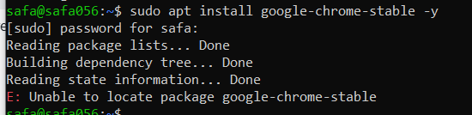
- task7_ls_etc_apt.png
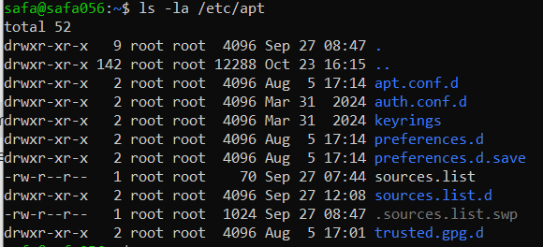
- task7_cat_sources_list.png
- task7_ls_sources_list_d.png
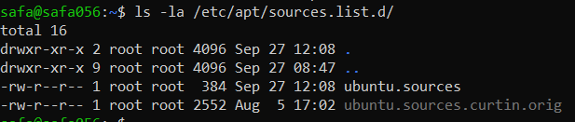
- task7_cat_ubuntu_sources.png
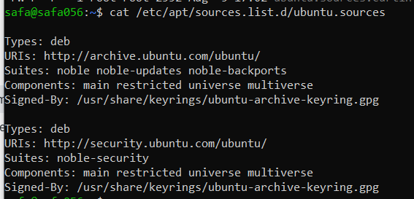
- task7_edit_ubuntu_sources.png
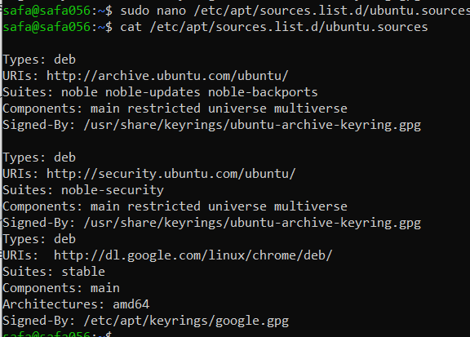
- task7_add_key.png
- task7_apt_update.png
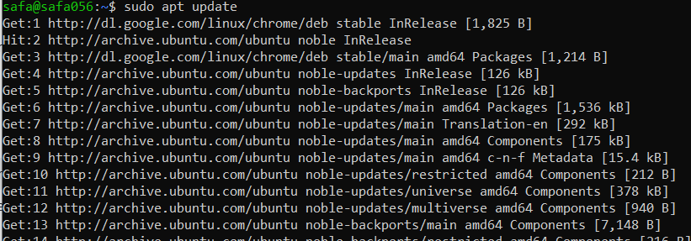
- task7_install_chrome.png
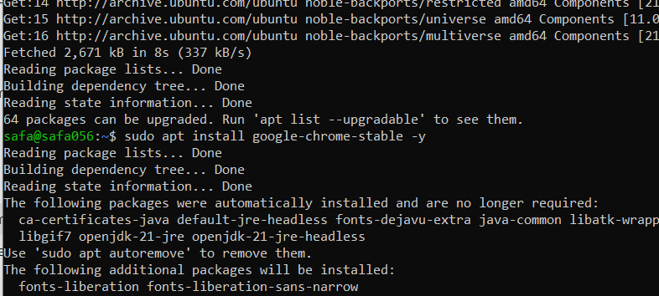
- task7_alternate_remove.png
- task7_alternate_edit.png
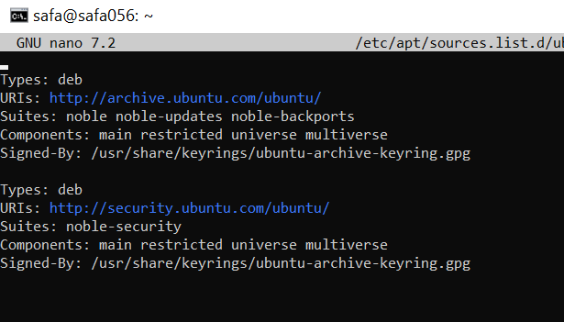
- task7_remove_key.png
- task7_create_google_chrome_list.png
- task7_list_sources_after_create.png
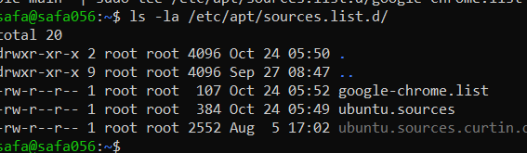
- task7_add_key_alt.png
- task7_apt_update_alt.png
- task7_install_chrome_alt.png
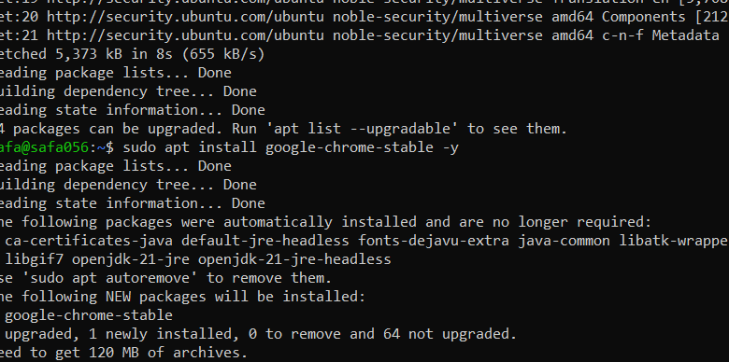

Task 8 - Install applications via PPA (Audacity & OBS) and launch
- task8_add_ppa_audacity.png
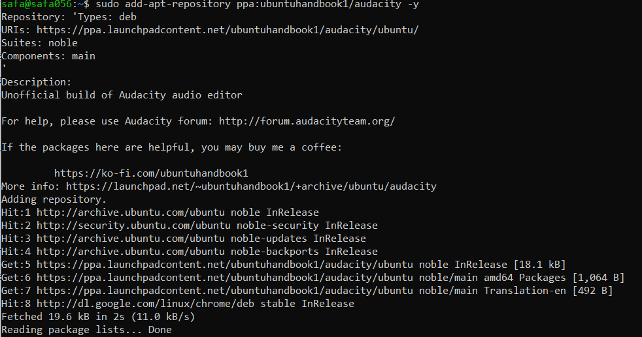
- task8_apt_update_audacity.png
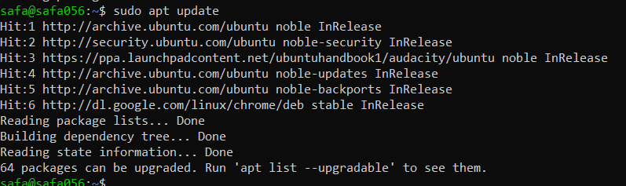
- task8_install_audacity.png
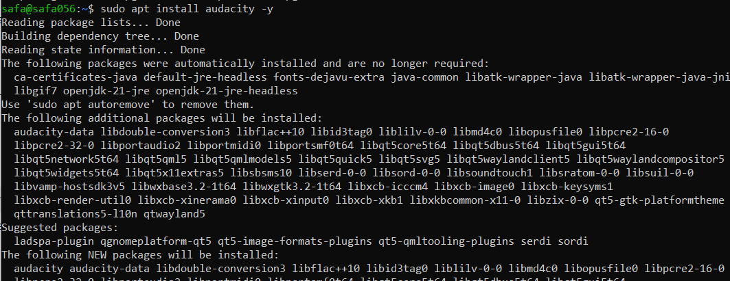
- task8_audacity_launch.png or task8_audacity_version.png
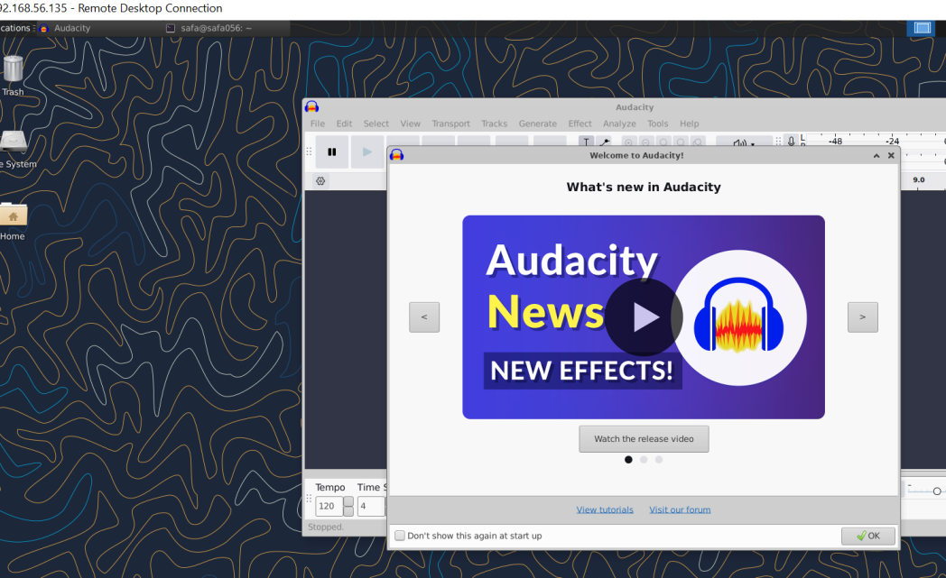
- task8_add_ppa_obs.png
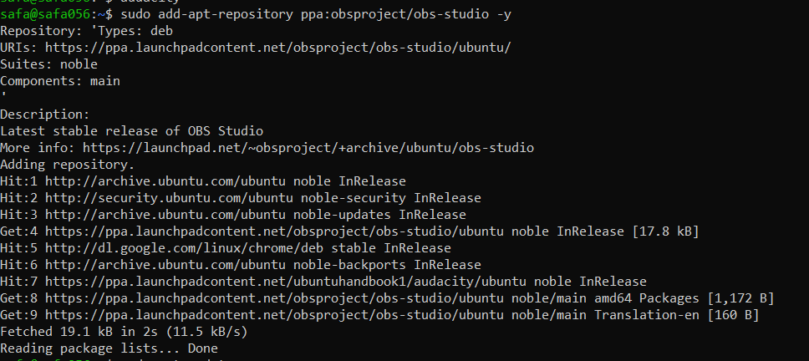
- task8_apt_update_obs.png
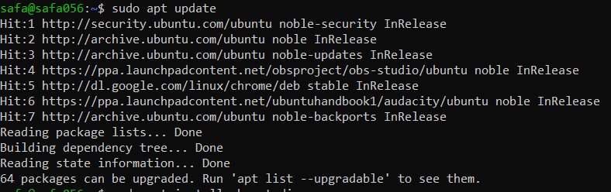
- task8_install_obs.png
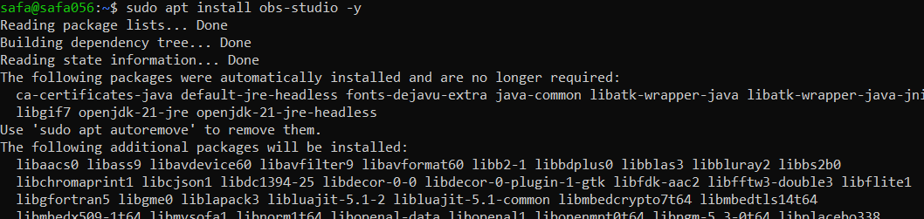
- task8_obs_launch.png or task8_obs_version.png
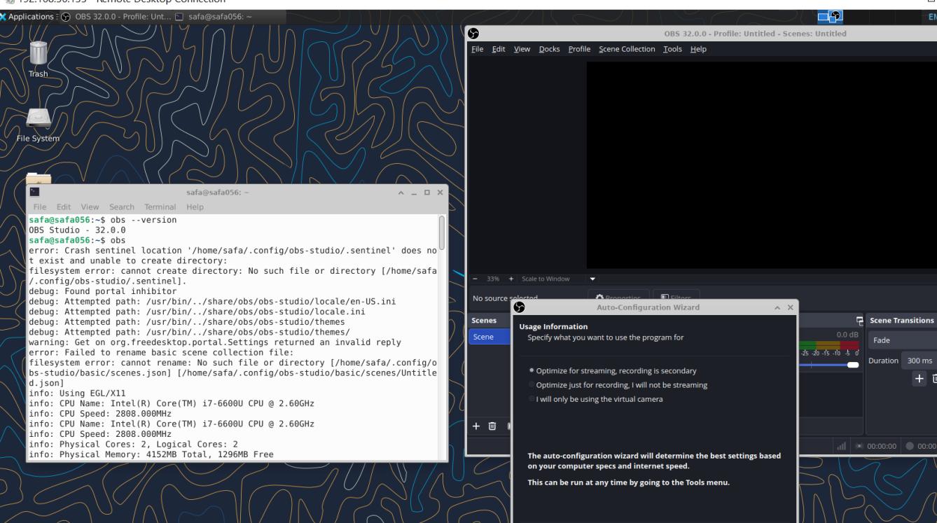

Task 9 - Create a Kubernetes sample YAML using vim
- task9_vim_check.png
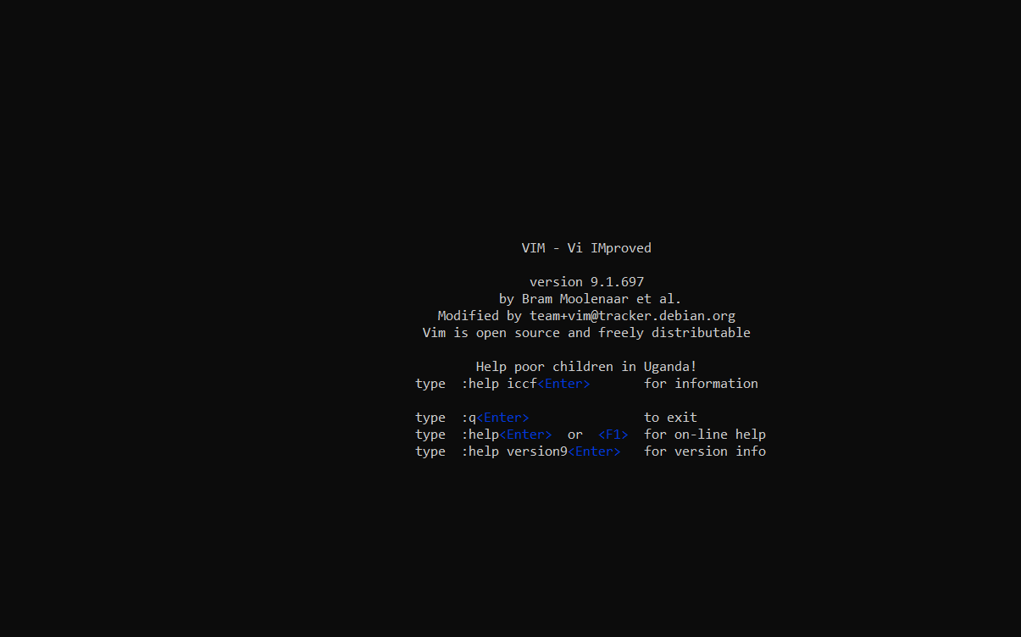
- task9_mkdir_cd.png
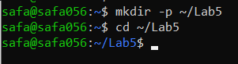
- task9_vim_edit.png
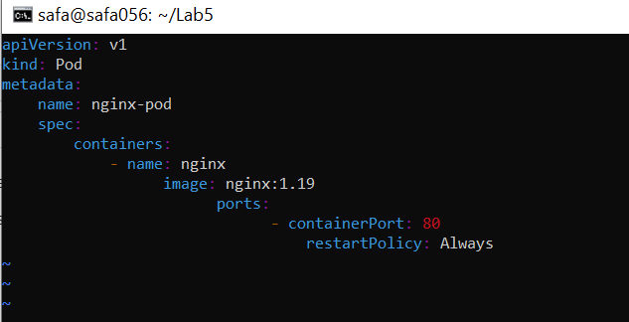
- task9_k8s_saved.png
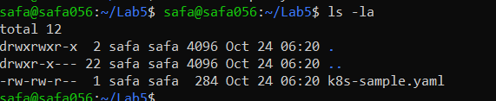

Task 10 - Edit the Kubernetes YAML - add annotation, verify, then discard temporary change
- task10_verify_annotation.png
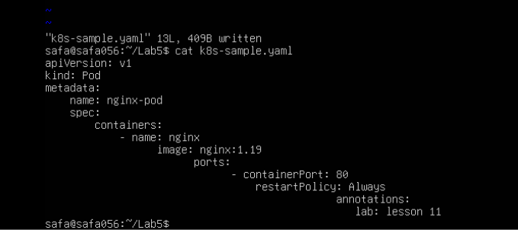
- task10_verify_entering_temp_data.png
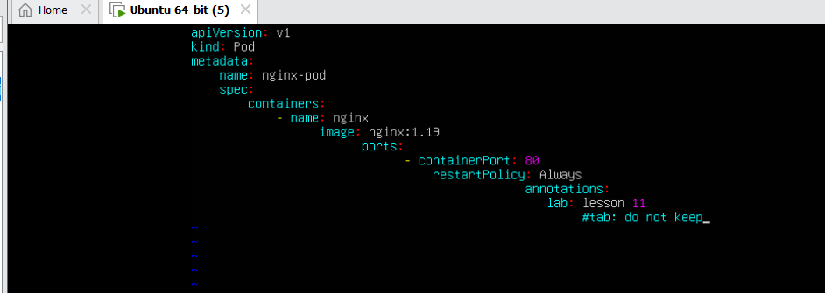
- task10_verify_no_temp_comment.png
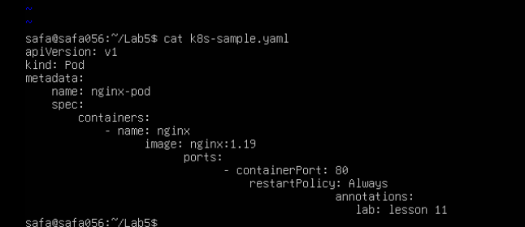

Task 11 - Vim editing practice - delete, undo, numeric deletes, and navigation
- task11_dd_delete_and_undo.png
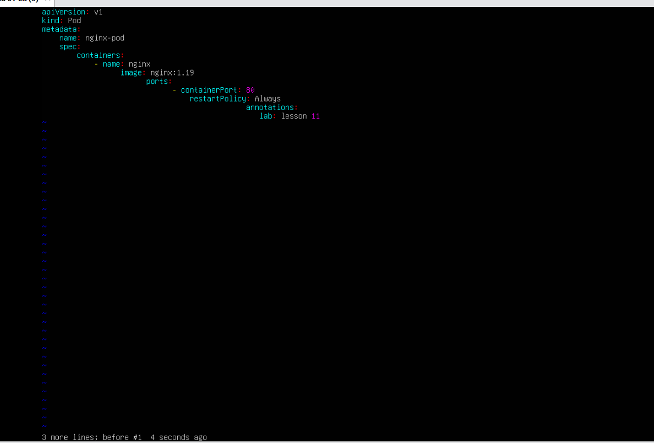
- task11_delete3_and_undo.png
- task11_line1.png
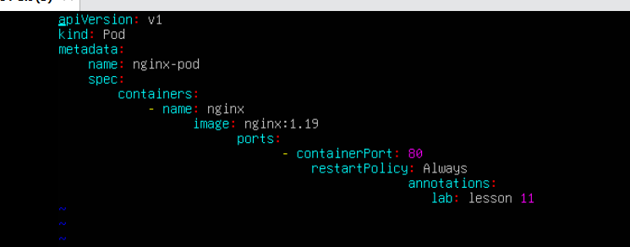
- task11_navigation.png
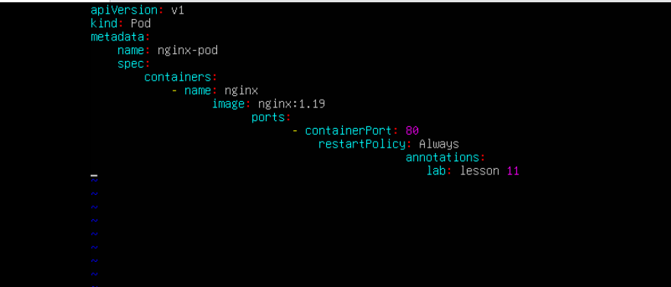

Task 12 - Vim search, add matches, substitute, undo
- task12_search_nginx.png
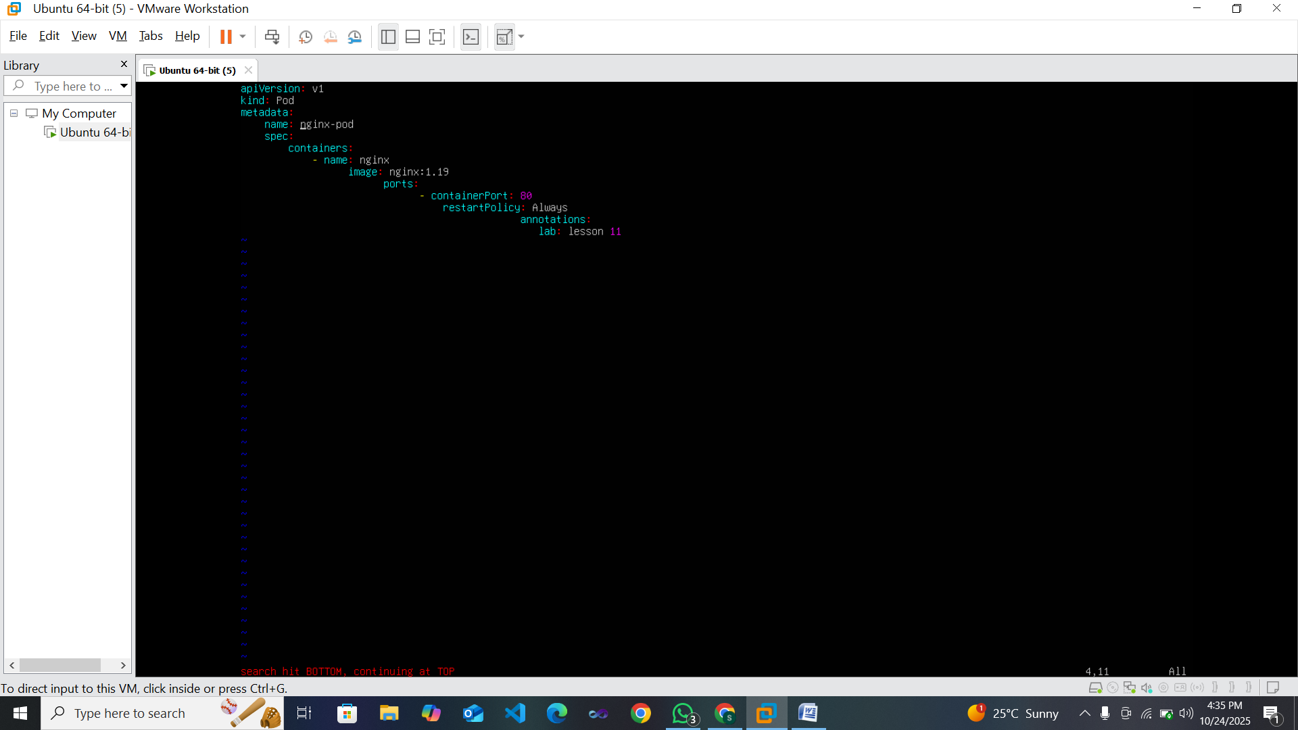
- task12_n_and_N_navigation.png
- task12_added_occurrences.png
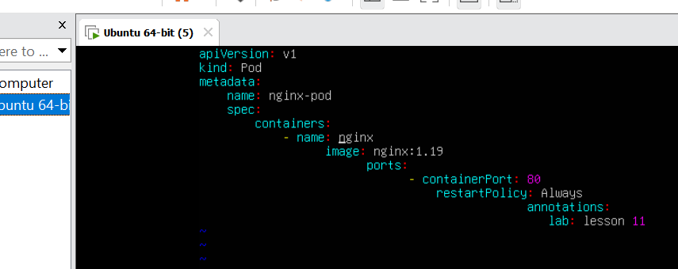
- task12_cycle_matches.png
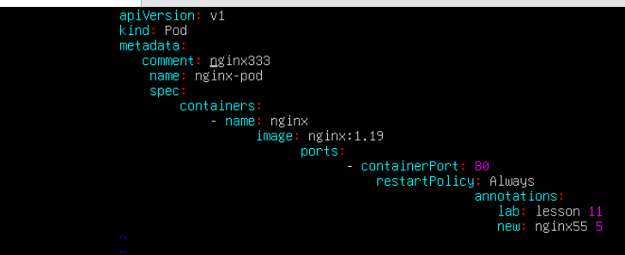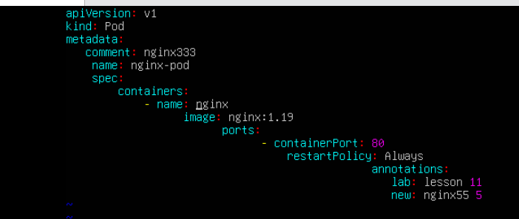
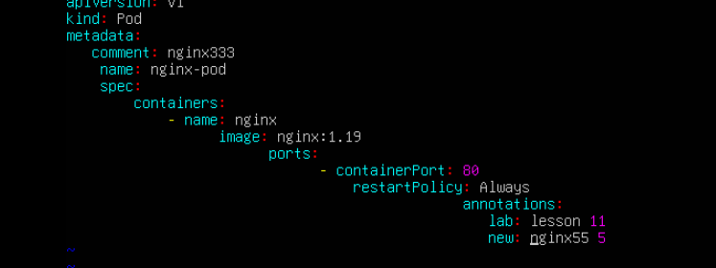
- task12_substitute_result.png
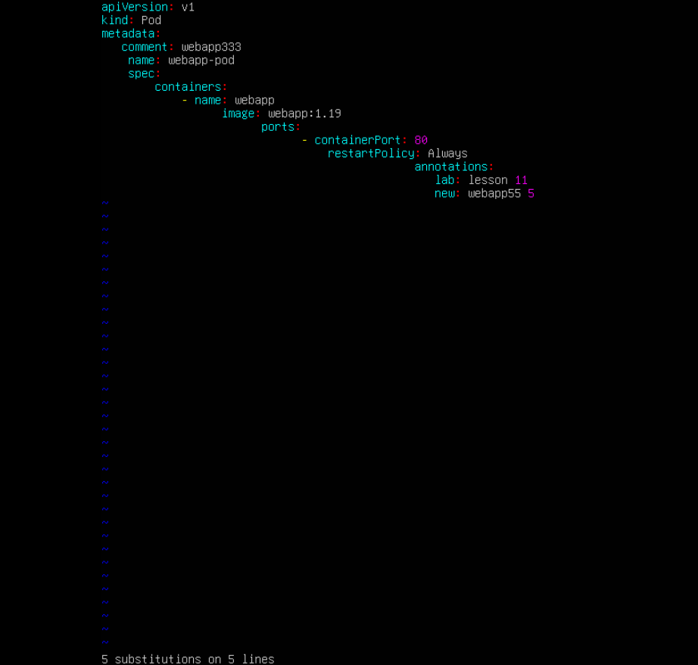
- task12_undo_and_quit.png
